**CHAPTER - 1**

**1. INTRODUCTION**

INTRODUCTION

Mobile advertising plays a vital role in the mobile app ecosystem. A recent report shows that mobile advertising expenditure worldwide is projected to reach $247.4 billion in 2020 [1]. To embed ads in an app, the app developer typically includes ad libraries provided by a third-party mobile ad provider such as AdMob [2]. When a mobile user is using the app, the embedded ad library fetches ad content from the network and displays ads to the user. The most common charging model is PPC (Pay-Per-Click) [3], where the developer and the ad provider get paid from the advertiser when a user clicks on the ad.

A major threat to the sustainability of this ecosystem is click fraud [4], i.e., clicks (i.e., touch events on mobile devices) on ads which are usually performed by malicious code programmatically or by automatic bot problems. There are many different click fraud tactics which can typically be characterized into two types: in-app frauds insert malicious code into the app to generate forged ad clicks; bots-driven frauds employ bot programs (e.g., a fraudulent application) to click on advertisements automatically. To quantify the inapp ad fraud in real apps, a recent work MAdFraud [5] conducts a large scale measurement about ad fraud in realworld apps.

In a dataset including about 130K Android apps, MAdFraud reports that about 30% of apps make ad requests while running in the background. Focusing on bots-driven click fraud, another recent work uses an automated click generation tool ClickDroid [4] to empirically evaluate eight popular advertising networks by performing real click fraud attacks on them. Results [4] show that six advertising networks out of eight are vulnerable to these attacks. Aiming at detecting click frauds in mobile apps, a straightforward approach is a threshold-based detection at the serverside. If an ad server is receiving a high number of clicks with the same device identifier (e.g., IP address) in a short period, these clicks can be considered as fraud. This straightforward approach, however, may suffer from high false negatives since the detection can be easily circumvented when the clicks are behind proxies or globally distributed. In the literature, there are also more sophisticated approaches [6], [7] focusing on detecting click frauds at the server-side.

The precisions of these server-side approaches, however, are not sufficient enough for the click fraud problem. For example, in a recent mobile ad fraud competition [6], the best three approaches achieve only a precision of 46.15% to 51.55% using various machine learning techniques. Given the insufficient precision of server-side approaches, a natural question comes up: how about client-side approaches? In fact, compared with the server-side approaches, it is easier to tell whether there is an actual user input at the client side. However, the attacker of the click fraud could be the app developers themselves, since the developers will get paid for those fraudulent ad clicks. Due to this conflict-of-interest problem, we cannot assume the existence of coordination from developers in designing a client-side approach for click fraud detection, e.g., a click fraud detection SDK. Therefore, in this paper, we focus on designing a client-side approach to detect click frauds in mobile apps, without coordination from developers.

There are two major challenges in designing such a system. First, for a mobile client, its resources are constrained in terms of computation, memory, and energy. Therefore, the proposed approach must perform the complete fraud detection process. See efficiently, without causing significant overhead. This means that we need to design new algorithms to detect click frauds since existing machine-learning algorithms used by server-side approaches are not suitable for the client side. Second, the click fraud detection should be able to execute under practical user scenarios, instead of a controlled environment dedicated to fraud detection. In MAdFraud [5], a controlled environment (i.e., only one app is running and the HTTP requests are collected for offline analysis) is used to measure the ad fraud behavior of a vast number of apps. However, in our case, the click fraud detection should happen inside the mobile client without outside support, i.e., be deployable in real-world scenarios.

In this paper, we propose AdSherlock, an efficient and deployable click fraud detection approach for mobile apps at the client side. Note that as a client-side approach, AdSherlock is orthogonal to existing server-side approaches. AdSherlock is designed to be used by app stores to ensure a healthy mobile app ecosystem. AdSherlock’s high accuracy helps market operators to fight both in-app frauds and bots-driven frauds. Note that, AdSherlock can also be used by any third parties to detect in-app frauds. For example, ad providers can employ AdSherlock to check whether apps embedding their libraries have in-app fraudulent behaviors. To achieve these goals, AdSherlock relies on an accurate offline pattern extractor and a lightweight online fraud detector. AdSherlock works in two stages. At the first stage, the offline pattern extractor automatically executes each app and generates a set of traffic patterns for efficient ad request identification, i.e., extracts common token patterns across different ad requests.

Specifically, after tokenization of the network requests, AdSherlock generates both exact patterns and probabilistic patterns for robust matching. Using the offline pattern extractor, AdSherlock can perform the computation and I/O intensive pattern generation operations in an offline manner, without degrading the online fraud detection operations. At the second stage, the online fraud detector as well as the generated patterns are instrumented into the app and run with the app in actual user scenarios. Inside the app, AdSherlock uses an ad request tree model to identify click requests accurately and efficiently. Since the online fraud detector runs inside the app, it can obtain the fine-grained user input events which are further employed for click fraud detection.

We implement AdSherlock and evaluate its performance using real apps. Results show that AdSherlock achieves higher click fraud detection accuracy compared with state of the art, with negligible runtime overhead.

The contributions of this paper are summarized as follows:

• We present the design and implementation of AdSherlock, the first system which can achieve efficient and deployable click fraud detection at the client side.

• We propose a pattern generation mechanism that generates patterns for ad requests and non-ad requests with high accuracy. We also propose an efficient method for online click fraud detection based on an ad request tree model.

• We implement AdSherlock and compare its performance with the state-of-art approach. Results show that Ad- Sherlock achieves higher detection accuracy with lower overhead.

**CHAPTER – 2**

**Literature Survey**

Research on ad frauds has been extensively carried in the realm of web applications. The relevant literature mostly focuses on click fraud which generally consists of leveraging a single computer or botnets to drive fake or undesirable impressions and clicks. A number of research studies have extensively characterized click frauds [1, 8, 46] and analysed its profit model [43]. Approaches have also been proposed to detect click frauds by analysing network traffic [44, 45] or by mining search engine’s query logs [63].

Nevertheless, despite the specificities of mobile development and usage models, the literature on in-app ad frauds is rather limited. One example of work is the DECAF [37] approach for detecting placement frauds: these consist in manipulating visual layouts of ad views (also referred to as elements or controls) to trigger undesirable impressions in Windows Phone apps. DECAF explores the UI states (which refer to snapshots of the UI when the app is running) in order to detect ad placement frauds implemented in the form of hidden ads, the stacking of multiple ads per page, etc. MAdFraud [13], on the other hand, targets Android apps to detect in-app click frauds by analysing network traffic.

Unfortunately, while the community still struggles to properly address well-known, and often trivial, cases of ad frauds, deception techniques used by app developers are even getting more sophisticated, as reported recently in news outlets [24, 31]. Indeed, besides the aforementioned click and placement frauds, many apps implement advanced procedures for tricking users into unintentionally clicking ad views while they are interacting with the app UI elements. In this work, we refer to this type of ad frauds as dynamic interaction frauds.

Figure 1 illustrates the case of the app taijiao music1 where an ad view gets unexpectedly popped up on top of the exit button when the user wants to exit the app: this usually leads to an unintentional ad click. Actually, we performed a user study on this app and found that 9 out of 10 users were tricked into clicking the ad view. To the best of our knowledge, such frauds have not yet been explored in the literature of mobile ad frauds, and are thus not addressed by the state-of-the-art detection approaches.

This paper. We perform an exploratory study of a wide range of new ad fraud types in Android apps and propose an automated approach for detecting them in market apps. To that end, we first provide a taxonomy that characterizes a variety of mobile ad frauds including both static placement frauds and dynamic interaction frauds. While detection of the former can be performed via analysing the static information of the layout in a single UI state [37], detection of the latter presents several challenges, notably for:

Dynamically exercising ad views in a UI state, achieving scalability, and ensuring good coverage in transitions between UI states: A UI state is a running page that contains several visual views/elements, also referred to as controls in Android documentation. Because dynamic interaction frauds involve sequences of UI states, a detection scheme must consider the transition between UI states, as well as background resource consumption such as network traffic. For example, in order to detect the ad fraud case presented in Figure 1, one needs to analyse both current and next UI states to identify any ad view that is placed on top of buttons and which could thus entice users to click on ads unexpectedly. Exercising apps to uncover such behaviours can however be timeconsuming: previous work has shown that it takes several hours to traverse the majority UI states of an app based on existing Android automation frameworks [33].

Automatically distinguishing ad views among other views: In contrast with UI on the Windows Phone platform targeted by the state-of-the-art (e.g., DECAF [37]), Android UI models are generic and thus it is challenging to identify ad views in a given UI state since no explicit labels are provided to distinguish them from other views (e.g., text views). During app development, a view can be added to the Activity, which represents a UI state implementation in Android, by either specifying it in the XML layout [18] or embedding it in the source code. In preliminary investigations, we found that most ad views are actually directly embedded in the code, thus preventing any identification via straightforward XML analysis.

Towards building an approach that achieves accuracy and scalability in Android ad fraud detection, we propose two key techniques aimed at addressing the aforementioned challenges:

Transition graph-based UI exploration. This technique builds a UI transition graph by simulating interaction events associated with user manipulation. We first capture the relationship between UI states through building the transition graphs between them, then identify ad views based on call stack traces and unique features gathered through comparing the ad views and other views in UI states. The scalability of this step is boosted by our proposed ad-first exploration strategy, which leverages probability distributions of the presence of an ad view in a UI state.

Heuristics-supported ad fraud detection. By manually investigating various real-world cases of ad frauds, we devise heuristic

rules from the observed characteristics of fraudulent behaviour. Runtime analysis focusing on various behavioural aspects such as view size, bounds, displayed strings or network traffic, is then mapped against the rules to detect ad frauds.

**CHAPTER – 3**

**System Analysis**

**3.1 Existing System**

since existing machine-learning algorithms used by server-side approaches are not suitable for the client side. Second, the click fraud detection should be able to execute under practical user scenarios, instead of a controlled environment dedicated to fraud detection. In MAdFraud [5], a controlled environment (i.e., only one app is running and the HTTP requests are collected for offline analysis) is used to measure the ad fraud behavior of a vast number of apps. However, in our case, the click fraud detection should happen inside the mobile client without outside support, i.e., be deployable in real-world scenarios. In this paper, we propose AdSherlock, an efficient and deployable click fraud detection approach for mobile apps at the client side. Note that as a client-side approach, AdSherlock is orthogonal to existing server-side approaches. AdSherlock is designed to be used by app stores to ensure a healthy mobile app ecosystem. AdSherlock’s high accuracy helps market operators to fight both in-app frauds and bots-driven frauds. Note that, AdSherlock can also be used by any third parties to detect in-app frauds. For example, ad providers can employ AdSherlock to check whether apps embedding their libraries have in-app fraudulent behaviors..

**3.2 Proposed System**

In order to solve the above problem

we propose two pattern classes: exact patterns and probabilistic patterns. Both of them are built from invariant substrings in the HTTP header. We refer to these substrings as tokens. Exact patterns consist of a set of sequential tokens and match an HTTP request if and only if the request contains all tokens in the set with the same ordering. Probabilistic patterns consist of a set of tokens, each of which is associated with an ad score, and a non-ad score. We describe the details of pattern generation in the following sections.

**3.3 Algorithms**

**3.3.1 AdSherlock**

An efficient and deployable click fraud detection approach for mobile apps at the client side. Note that as a client-side approach, AdSherlock is orthogonal to existing server-side approaches. AdSherlock is designed to be used by app stores to ensure a healthy mobile app ecosystem. AdSherlock’s high accuracy helps market operators to fight both in-app frauds and bots-driven frauds. Note that, AdSherlock can also be used by any third parties to detect in-app frauds. For example, ad providers can employ AdSherlock to check whether apps embedding their libraries have in-app fraudulent behaviors.

**3.4 Feasibility Study**

The feasibility of the project is analyzed in this phase and business proposal is put forth with a very general plan for the project and some cost estimates. During system analysis the feasibility study of the proposed system is to be carried out. This is to ensure that the proposed system is not a burden to the company. For feasibility analysis, some understanding of the major requirements for the system is essential.

**Three key considerations involved in the feasibility analysis are,**

* **ECONOMICAL FEASIBILITY**
* **TECHNICAL FEASIBILITY**
* **SOCIAL FEASIBILITY**

**3.5. Economic Feasibility**

This study is carried out to check the economic impact that the system will have on the organization. The amount of fund that the company can pour into the research and development of the system is limited. The expenditures must be justified. Thus the developed system as well within the budget and this was achieved because most of the technologies used are freely available. Only the customized products had to be purchased.

**3.6 Technical Feasibility**

This study is carried out to check the technical feasibility, that is, the technical requirements of the system. Any system developed must not have a high demand on the available technical resources. This will lead to high demands on the available technical resources. This will lead to high demands being placed on the client. The developed system must have a modest requirement, as only minimal or null changes are required for implementing this system.

**3.7 Social Feasibility**

The aspect of study is to check the level of acceptance of the system by the user. This includes the process of training the user to use the system efficiently. The user must not feel threatened by the system, instead must accept it as a necessity. The level of acceptance by the users solely depends on the methods that are employed to educate the user about the system and to make him familiar with it. His level of confidence must be raised so that he is also able to make some constructive criticism, which is welcomed, as he is the final user of the system.

**CHAPTER – 4**

**SYSTEM REQUIREMENTS SPECIFICATION**

**4.1 Introduction**

**PYTHON**

Python is a general-purpose interpreted, interactive, object-oriented, and high-level programming language. An interpreted language, Python has a design philosophy that emphasizes code readability (notably using whitespace indentation to delimit code blocks rather than curly brackets or keywords), and a syntax that allows programmers to express concepts in fewer lines of code than might be used in languages such as C++or Java. It provides constructs that enable clear programming on both small and large scales. Python interpreters are available for many operating systems. CPython, the reference implementation of Python, is open source software and has a community-based development model, as do nearly all of its variant implementations. CPython is managed by the non-profit Python Software Foundation. Python features a dynamic type system and automatic memory management. It supports multiple programming paradigms, including object-oriented, imperative, functional and procedural, and has a large and comprehensive standard library

**DJANGO**

Django is a high-level Python Web framework that encourages rapid development and clean, pragmatic design. Built by experienced developers, it takes care of much of the hassle of Web development, so you can focus on writing your app without needing to reinvent the wheel. It’s free and open source.

Django's primary goal is to ease the creation of complex, database-driven websites. Django emphasizes [reusability](https://en.wikipedia.org/wiki/Reusability)and "pluggability" of components, rapid development, and the principle of [don't repeat yourself](https://en.wikipedia.org/wiki/Don%27t_repeat_yourself). Python is used throughout, even for settings files and data models.

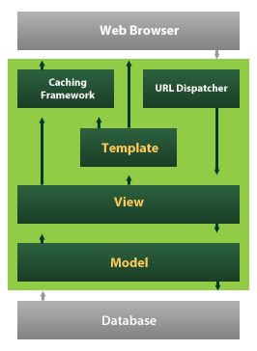

Django also provides an optional administrative [create, read, update and delete](https://en.wikipedia.org/wiki/Create,_read,_update_and_delete) interface that is generated dynamically through [introspection](https://en.wikipedia.org/wiki/Introspection_(computer_science)) and configured via admin models

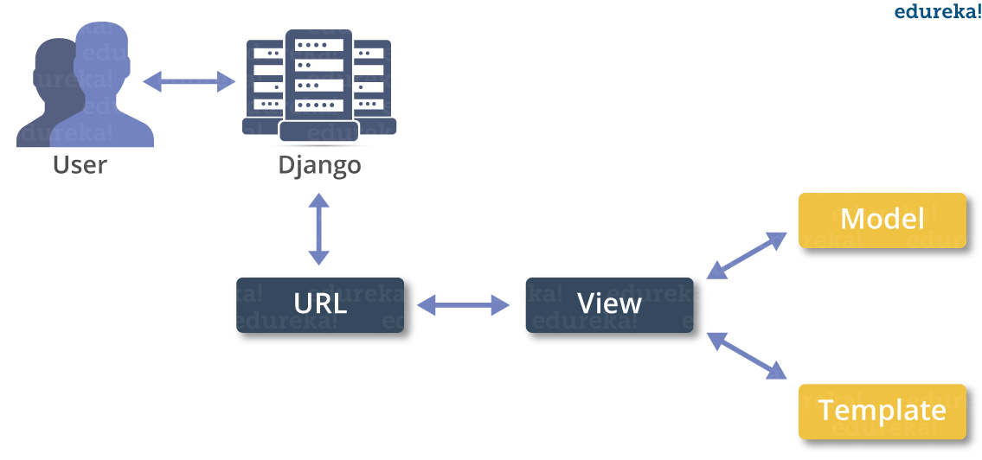

**4.2 Purpose**

The project involved analyzing the design of few applications so as to make the application more users friendly. To do so, it was really important to keep the navigations from one screen to the other well ordered and at the same time reducing the amount of typing the user needs to do. In order to make the application more accessible, the browser version had to be chosen so that it is compatible with most of the Browsers.

**4.3 Functional Requirements**

* Graphical User interface with the User.

**4.4 Non Functional Requirements**

• **Maintainability:** Maintainability is used to make future maintenance easier, meet new requirements. Our project can support expansion.

• **Robustness:** Robustness is the quality of being able to withstand stress, pressures or changes in procedure or circumstance. Our project also provides it.

• **Reliability:** Reliability is an ability of a person or system to perform and maintain its functions in circumstances. Our project also provides it.

• **Size:** The size of a particular application plays a major role, if the size is less then efficiency will be high. The size of database we have developed is 5.05 MB.

• **Speed:** If the speed is high then it is good. Since the no of lines in our code is less, hence the speed is high.

• **Power Consumption:** In battery-powered systems, power consumption is very important. In the requirement stage, power can be specified in terms of battery life.

However the allowable wattage can’t be defined by the customer. Since the no of lines

of code is less CPU uses less time to execute hence power usage will be less.

**4.5 Input & Output Design**

**INPUT DESIGN**

The input design is the link between the information system and the user. It comprises the developing specification and procedures for data preparation and those steps are necessary to put transaction data in to a usable form for processing can be achieved by inspecting the computer to read data from a written or printed document or it can occur by having people keying the data directly into the system. The design of input focuses on controlling the amount of input required, controlling the errors, avoiding delay, avoiding extra steps and keeping the process simple. The input is designed in such a way so that it provides security and ease of use with retaining the privacy. Input Design considered the following things:

* What data should be given as input?
* How the data should be arranged or coded?
* The dialog to guide the operating personnel in providing input.
* Methods for preparing input validations and steps to follow when error occur.

**OBJECTIVES**

1.Input Design is the process of converting a user-oriented description of the input into a computer-based system. This design is important to avoid errors in the data input process and show the correct direction to the management for getting correct information from the computerized system.

2. It is achieved by creating user-friendly screens for the data entry to handle large volume of data. The goal of designing input is to make data entry easier and to be free from errors. The data entry screen is designed in such a way that all the data manipulates can be performed. It also provides record viewing facilities.

3.When the data is entered it will check for its validity. Data can be entered with the help of screens. Appropriate messages are provided as when needed so that the user will not be in maize of instant. Thus the objective of input design is to create an input layout that is easy to follow

**OUTPUT DESIGN**

A quality output is one, which meets the requirements of the end user and presents the information clearly. In any system results of processing are communicated to the users and to other system through outputs. In output design it is determined how the information is to be displaced for immediate need and also the hard copy output. It is the most important and direct source information to the user. Efficient and intelligent output design improves the system’s relationship to help user decision-making.

1. Designing computer output should proceed in an organized, well thought out manner; the right output must be developed while ensuring that each output element is designed so that people will find the system can use easily and effectively. When analysis design computer output, they should Identify the specific output that is needed to meet the requirements.

2.Select methods for presenting information.

3.Create document, report, or other formats that contain information produced by the system.

The output form of an information system should accomplish one or more of the following objectives.

* Convey information about past activities, current status or projections of the
* Future.
* Signal important events, opportunities, problems, or warnings.
* Trigger an action.
* Confirm an action.

**4.6 Hardware Requirements**

* **System :** Pentium IV 2.4 GHz.
* **Hard Disk :** 40 GB.
* **Floppy Drive :** 1.44 Mb.
* **Monitor** : 14’ Colour Monitor.
* **Mouse :** Optical Mouse.
* **Ram :** 512 Mb.

**4.7 Software Requirements**

* **Operating system :** Windows 7 Ultimate.
* **Coding Language :** Python.
* **Front-End :** Python.
* **Designing :** Html,css,javascript.
* **Data Base :** MySQL.

**CHAPTER – 5**

**System Design**

**5.1 System Specifications**

**REQUIREMENT ANALYSIS**

The project involved analyzing the design of few applications so as to make the application more users friendly. To do so, it was really important to keep the navigations from one screen to the other well ordered and at the same time reducing the amount of typing the user needs to do. In order to make the application more accessible, the browser version had to be chosen so that it is compatible with most of the Browsers.

**REQUIREMENT SPECIFICATION**

**Functional Requirements**

* Graphical User interface with the User.

**Software Requirements**

For developing the application the following are the Software Requirements:

1. Python
2. Django

**Operating Systems supported**

1. Windows 7
2. Windows XP
3. Windows 8

**Technologies and Languages used to Develop**

1. Python

**Debugger and Emulator**

* Any Browser (Particularly Chrome)

**Hardware Requirements**

For developing the application the following are the Hardware Requirements:

* Processor: Pentium IV or higher
* RAM: 256 MB
* Space on Hard Disk: minimum 512MB

**5.2 System Architecture**

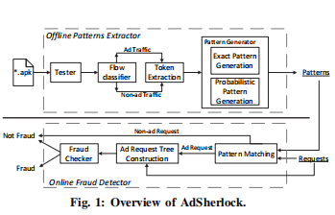

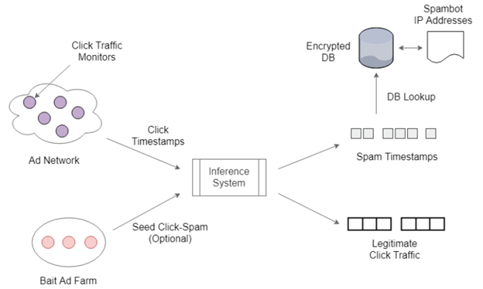

Figure : System Architecture

**5.3 Flowcharts**

Flow chart" redirects here. For the poem, see Flow Chart (poem). For the music group, see Flowchart (band).

A simple flowchart representing a process for dealing with a non-functioning lamp.

A flowchart is a type of diagram that represents a workflow or process. A flowchart can also be defined as a diagrammatic representation of an algorithm, a step-by-step approach to solving a task.

The flowchart shows the steps as boxes of various kinds, and their order by connecting the boxes with arrows. This diagrammatic representation illustrates a solution model to a given problem. Flowcharts are used in analyzing, designing, documenting or managing a process or program in various fields.[1]

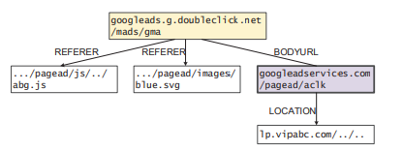

**5.5 UML Diagrams**

UML stands for Unified Modeling Language. UML is a standardized general-purpose modeling language in the field of object-oriented software engineering. The standard is managed, and was created by, the Object Management Group.

The goal is for UML to become a common language for creating models of object oriented computer software. In its current form UML is comprised of two major components: a Meta-model and a notation. In the future, some form of method or process may also be added to; or associated with, UML.

The Unified Modeling Language is a standard language for specifying, Visualization, Constructing and documenting the artifacts of software system, as well as for business modeling and other non-software systems.

The UML represents a collection of best engineering practices that have proven successful in the modeling of large and complex systems.

The UML is a very important part of developing objects oriented software and the software development process. The UML uses mostly graphical notations to express the design of software projects.

**GOALS:**

The Primary goals in the design of the UML are as follows:

1. Provide users a ready-to-use, expressive visual modeling Language so that they can develop and exchange meaningful models.
2. Provide extendibility and specialization mechanisms to extend the core concepts.
3. Be independent of particular programming languages and development process.
4. Provide a formal basis for understanding the modeling language.
5. Encourage the growth of OO tools market.
6. Support higher level development concepts such as collaborations, frameworks, patterns and components.

7. Integrate best practices.

**CLASS DIAGRAM**

In software engineering, a class diagram in the Unified Modeling Language (UML) is a type of static structure diagram that describes the structure of a system by showing the system's classes, their attributes, operations (or methods), and the relationships among the classes. It explains which class contains information.



**USE CASE DIAGRAM**

A use case diagram in the Unified Modeling Language (UML) is a type of behavioral diagram defined by and created from a Use-case analysis. Its purpose is to present a graphical overview of the functionality provided by a system in terms of actors, their goals (represented as use cases), and any dependencies between those use cases. The main purpose of a use case diagram is to show what system functions are performed for which actor. Roles of the actors in the system can be depicted.





**SEQUENCE DIAGRAM**

A sequence diagram in Unified Modeling Language (UML) is a kind of interaction diagram that shows how processes operate with one another and in what order. It is a construct of a Message Sequence Chart. Sequence diagrams are sometimes called event diagrams, event scenarios, and timing diagrams.



**Collaboration diagram**

A collaboration diagram, also known as a communication diagram, is an illustration of the relationships and interactions among software objects in the Unified Modeling Language (UML). These diagrams can be used to portray the dynamic behavior of a particular use case and define the role of each object.

A Communication diagram models the interactions between objects or parts in terms of sequenced messages. Communication diagrams represent a combination of information taken from [Class](https://en.wikipedia.org/wiki/Class_diagram), [Sequence](https://en.wikipedia.org/wiki/Sequence_diagram), and [Use Case Diagrams](https://en.wikipedia.org/wiki/Use_case_diagram) describing both the static structure and dynamic behavior of a system.

However, communication diagrams use the free-form arrangement of objects and links as used in Object diagrams. In order to maintain the ordering of messages in such a free-form diagram, messages are labeled with a chronological number and placed near the link the message is sent over. Reading a communication diagram involves starting at message 1.0, and following the messages from object to object.



**Deployment diagram**

A deployment diagram in the Unified Modeling Language models the physical deployment of artifacts on nodes.[1] To describe a web site, for example, a deployment diagram would show what hardware components ("nodes") exist (e.g., a web server, an application server, and a database server), what software components ("artifacts") run on each node (e.g., web application, database), and how the different pieces are connected (e.g. JDBC, REST, RMI).

The nodes appear as boxes, and the artifacts allocated to each node appear as rectangles within the boxes. Nodes may have subnodes, which appear as nested boxes. A single node in a deployment diagram may conceptually represent multiple physical nodes, such as a cluster of database servers.

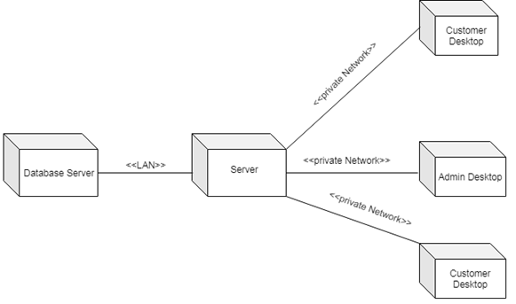

**Package Diagram**

Package diagram is UML structure diagram which shows structure of the designed system at the level of packages. The following elements are typically drawn in a package diagram: package, packageable element, dependency, element import, package import, package merge.

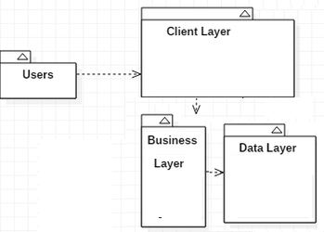

**Profile Diagram**

A Profile diagram is any diagram created in a «profile» Package. Profiles provide a means of extending the UML. They are based on additional stereotypes and Tagged Values that are applied to UML elements, connectors and their components.

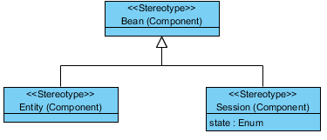

**CHAPTER – 6**

**IMPLEMENTATION**

**6.1 Modules Description**

**Dynamically exercising ad views in a UI state**

achieving scalability, and ensuring good coverage in transitions between UI states: A UI state is a running page that contains several visual views/elements, also referred to as controls in Android documentation. Because dynamic interaction frauds involve sequences of UI states, a detection scheme must consider the transition between UI states, as well as background resource consumption such as network traffic. For example, in order to detect the ad fraud case presented in Figure 1, one needs to analyse both current and next UI states to identify any ad view that is placed on top of buttons and which could thus entice users to click on ads unexpectedly. Exercising apps to uncover such behaviours can however be timeconsuming: previous work has shown that it takes several hours to traverse the majority UI states of an app based on existing Android automation frameworks [33].

**Automatically distinguishing ad views among other views**

In contrast with UI on the Windows Phone platform targeted by the state-of-the-art (e.g., DECAF [37]), Android UI models are generic and thus it is challenging to identify ad views in a given UI state since no explicit labels are provided to distinguish them from other views (e.g., text views). During app development, a view can be added to the Activity, which represents a UI state implementation in Android, by either specifying it in the XML layout [18] or embedding it in the source code. In preliminary investigations, we found that most ad views are actually directly embedded in the code, thus preventing any identification via straightforward XML analysis

**Ad Frauds**

While the literature contains a large body of work on placement frauds in web applications and the Windows Phone platform, very little attention has been paid to such frauds on Android. Furthermore, dynamic interaction frauds have even not been explored to the best of our knowledge. To build the taxonomy of Android ad frauds, we investigate in this work: (1) the usage policies provided by popular ad libraries [22, 26], (2) the developer policies provided by official Google Play market [49] and popular third-party app markets, including Wandoujia (Alibaba App) Market [60], Huawei App Market [41] and Tencent Myapp Market [42]. (3) the guidelines on ad behaviour drafted by a communication standards association [6], and (4) some real-world ad fraud cases. Figure 3 presents our taxonomy, which summarizes 9 different types of ad frauds, which represents by far the largest number of ad fraud types. Particularly, the five types of dynamic interaction frauds have never been investigated in the literature.

**FRAUDDROID**

To address ad frauds in the Android ecosystem we design and implement FraudDroid, an approach that combines dynamic analysis on UI state as well as network traffic data to identify fraudulent behaviours. Figure 4 illustrates the overall architecture of FraudDroid. The working process unfolds in two steps: (1) analysis and modelling of UI states, and (2) heuristics-based detection of ad frauds. To efficiently search for ad frauds, one possible step before sending apps to FraudDroid is to focus on such apps that have included ad libraries. To this end, FraudDroid integrates a pre-processing step, which stops the analysis if the input app does not leverage any ad libraries, i.e., there will be no ad frauds in that app. Thus we first propose to filter apps that have no permissions associated with the functioning of ad libraries, namely INTERNET and ACCESS_NETWORK_STATE [34].

**CHAPTER – 7**

**TECHNOLOGY DESCRIPTION**

Python is a general-purpose interpreted, interactive, object-oriented, and high-level programming language. An [interpreted language](https://en.wikipedia.org/wiki/Interpreted_language), Python has a design philosophy that emphasizes code [readability](https://en.wikipedia.org/wiki/Readability) (notably using [whitespace](https://en.wikipedia.org/wiki/Whitespace_character) indentation to delimit [code blocks](https://en.wikipedia.org/wiki/Code_block) rather than curly brackets or keywords), and a syntax that allows programmers to express concepts in fewer [lines of code](https://en.wikipedia.org/wiki/Source_lines_of_code) than might be used in languages such as [C++](https://en.wikipedia.org/wiki/C%2B%2B)or [Java](https://en.wikipedia.org/wiki/Java_(programming_language)). It provides constructs that enable clear programming on both small and large scales. Python interpreters are available for many [operating systems](https://en.wikipedia.org/wiki/Operating_system). [CPython](https://en.wikipedia.org/wiki/CPython), the [reference implementation](https://en.wikipedia.org/wiki/Reference_implementation) of Python, is [open source](https://en.wikipedia.org/wiki/Open_source) software and has a community-based development model, as do nearly all of its variant implementations. CPython is managed by the non-profit [Python Software Foundation](https://en.wikipedia.org/wiki/Python_Software_Foundation). Python features a [dynamic type](https://en.wikipedia.org/wiki/Dynamic_type) system and automatic [memory management](https://en.wikipedia.org/wiki/Memory_management). It supports multiple [programming paradigms](https://en.wikipedia.org/wiki/Programming_paradigm), including [object-oriented](https://en.wikipedia.org/wiki/Object-oriented_programming), [imperative](https://en.wikipedia.org/wiki/Imperative_programming), [functional](https://en.wikipedia.org/wiki/Functional_programming) and [procedural](https://en.wikipedia.org/wiki/Procedural_programming), and has a large and comprehensive [standard library](https://en.wikipedia.org/wiki/Standard_library)

## What is Python

## **Python is a popular programming language. It was created by Guido van Rossum, and released in 1991.**

**It is used for:**

* web development (server-side),
* software development,
* mathematics,
* system scripting.

### What can Python do

* Python can be used on a server to create web applications.
* Python can be used alongside software to create workflows.
* Python can connect to database systems. It can also read and modify files.
* Python can be used to handle big data and perform complex mathematics.
* Python can be used for rapid prototyping, or for production-ready software development.

### Why Python

* Python works on different platforms (Windows, Mac, Linux, Raspberry Pi, etc).
* Python has a simple syntax similar to the English language.
* Python has syntax that allows developers to write programs with fewer lines than some other programming languages.
* Python runs on an interpreter system, meaning that code can be executed as soon as it is written. This means that prototyping can be very quick.
* Python can be treated in a procedural way, an object-orientated way or a functional way.

### Good to know

* The most recent major version of Python is Python 3, which we shall be using in this tutorial. However, Python 2, although not being updated with anything other than security updates, is still quite popular.
* In this tutorial Python will be written in a text editor. It is possible to write Python in an Integrated Development Environment, such as Thonny, Pycharm, Netbeans or Eclipse which are particularly useful when managing larger collections of Python files.

### Python Syntax compared to other programming languages

* Python was designed for readability, and has some similarities to the English language with influence from mathematics.
* Python uses new lines to complete a command, as opposed to other programming languages which often use semicolons or parentheses.
* Python relies on indentation, using whitespace, to define scope; such as the scope of loops, functions and classes. Other programming languages often use curly-brackets for this purpose.

**Python Install**

Many PCs and Macs will have python already installed.

To check if you have python installed on a Windows PC, search in the start bar for Python or run the following on the Command Line (cmd.exe):

C:\Users\Your Name>python --version

To check if you have python installed on a Linux or Mac, then on linux open the command line or on Mac open the Terminal and type:

python --version

If you find that you do not have python installed on your computer, then you can download it for free from the following website: https://www.python.org/

Python Quickstart

Python is an interpreted programming language, this means that as a developer you write Python (.py) files in a text editor and then put those files into the python interpreter to be executed.

The way to run a python file is like this on the command line:

C:\Users\Your Name>python helloworld.py

Where "helloworld.py" is the name of your python file.

Let's write our first Python file, called helloworld.py, which can be done in any text editor.

helloworld.py

print("Hello, World!")

Simple as that. Save your file. Open your command line, navigate to the directory where you saved your file, and run:

C:\Users\Your Name>python helloworld.py

The output should read:

Hello, World!

Congratulations, you have written and executed your first Python program.

The Python Command Line

To test a short amount of code in python sometimes it is quickest and easiest not to write the code in a file. This is made possible because Python can be run as a command line itself.

Type the following on the Windows, Mac or Linux command line:

C:\Users\Your Name>python

Or, if the "python" command did not work, you can try "py":

C:\Users\Your Name>py

From there you can write any python, including our hello world example from earlier in the tutorial:

C:\Users\Your Name>python

Python 3.6.4 (v3.6.4:d48eceb, Dec 19 2017, 06:04:45) [MSC v.1900 32 bit (Intel)] on win32

Type "help", "copyright", "credits" or "license" for more information.

>>>print("Hello, World!")

Which will write "Hello, World!" in the command line:

C:\Users\Your Name>python

Python 3.6.4 (v3.6.4:d48eceb, Dec 19 2017, 06:04:45) [MSC v.1900 32 bit (Intel)] on win32

Type "help", "copyright", "credits" or "license" for more information.

>>>print("Hello, World!")

Hello, World!

Whenever you are done in the python command line, you can simply type the following to quit the python command line interface:

exit()

**Virtual Environments and Packages**

**Introduction**

Python applications will often use packages and modules that don’t come as part of the standard library. Applications will sometimes need a specific version of a library, because the application may require that a particular bug has been fixed or the application may be written using an obsolete version of the library’s interface.

This means it may not be possible for one Python installation to meet the requirements of every application. If application A needs version 1.0 of a particular module but application B needs version 2.0, then the requirements are in conflict and installing either version 1.0 or 2.0 will leave one application unable to run.

The solution for this problem is to create a virtual environment, a self-contained directory tree that contains a Python installation for a particular version of Python, plus a number of additional packages.

Different applications can then use different virtual environments. To resolve the earlier example of conflicting requirements, application A can have its own virtual environment with version 1.0 installed while application B has another virtual environment with version 2.0. If application B requires a library be upgraded to version 3.0, this will not affect application A’s environment.

**Creating Virtual Environments**

The module used to create and manage virtual environments is called venv. venv will usually install the most recent version of Python that you have available. If you have multiple versions of Python on your system, you can select a specific Python version by running python3 or whichever version you want.

To create a virtual environment, decide upon a directory where you want to place it, and run the venv module as a script with the directory path:

python3 -m venv tutorial-env

This will create the tutorial-env directory if it doesn’t exist, and also create directories inside it containing a copy of the Python interpreter, the standard library, and various supporting files.

A common directory location for a virtual environment is .venv. This name keeps the directory typically hidden in your shell and thus out of the way while giving it a name that explains why the directory exists. It also prevents clashing with .env environment variable definition files that some tooling supports.

Once you’ve created a virtual environment, you may activate it.

On Windows, run:

tutorial-env\Scripts\activate.bat

On Unix or MacOS, run:

source tutorial-env/bin/activate

(This script is written for the bash shell. If you use the csh or fish shells, there are alternate activate.csh and activate.fish scripts you should use instead.)

Activating the virtual environment will change your shell’s prompt to show what virtual environment you’re using, and modify the environment so that running python will get you that particular version and installation of Python. For example:

$ source ~/envs/tutorial-env/bin/activate

(tutorial-env) $ python

Python 3.5.1 (default, May 6 2016, 10:59:36)

...

>>> import sys

>>>sys.path

['', '/usr/local/lib/python35.zip', ...,

'~/envs/tutorial-env/lib/python3.5/site-packages']

>>>

12.3. Managing Packages with pip

You can install, upgrade, and remove packages using a program called pip. By default pip will install packages from the Python Package Index, <https://pypi.org>. You can browse the Python Package Index by going to it in your web browser, or you can use pip’s limited search feature:

(tutorial-env) $ pip search astronomy

skyfield - Elegant astronomy for Python

gary - Galactic astronomy and gravitational dynamics.

novas - The United States Naval Observatory NOVAS astronomy library

astroobs - Provides astronomy ephemeris to plan telescope observations

PyAstronomy - A collection of astronomy related tools for Python.

...

pip has a number of subcommands: “search”, “install”, “uninstall”, “freeze”, etc. (Consult the Installing Python Modules guide for complete documentation for pip.)

You can install the latest version of a package by specifying a package’s name:

(tutorial-env) $ pip install novas

Collecting novas

Downloading novas-3.1.1.3.tar.gz (136kB)

Installing collected packages: novas

Running setup.py install for novas

Successfully installed novas-3.1.1.3

You can also install a specific version of a package by giving the package name followed by == and the version number:

(tutorial-env) $ pip install requests==2.6.0

Collecting requests==2.6.0

Using cached requests-2.6.0-py2.py3-none-any.whl

Installing collected packages: requests

Successfully installed requests-2.6.0

If you re-run this command, pip will notice that the requested version is already installed and do nothing. You can supply a different version number to get that version, or you can run pip install --upgrade to upgrade the package to the latest version:

(tutorial-env) $ pip install --upgrade requests

Collecting requests

Installing collected packages: requests

Found existing installation: requests 2.6.0

Uninstalling requests-2.6.0:

Successfully uninstalled requests-2.6.0

Successfully installed requests-2.7.0

pip uninstall followed by one or more package names will remove the packages from the virtual environment.

pip show will display information about a particular package:

(tutorial-env) $ pip show requests

---

Metadata-Version: 2.0

Name: requests

Version: 2.7.0

Summary: Python HTTP for Humans.

Home-page: http://python-requests.org

Author: Kenneth Reitz

Author-email: me@kennethreitz.com

License: Apache 2.0

Location: /Users/akuchling/envs/tutorial-env/lib/python3.4/site-packages

Requires:

pip list will display all of the packages installed in the virtual environment:

(tutorial-env) $ pip list

novas (3.1.1.3)

numpy (1.9.2)

pip (7.0.3)

requests (2.7.0)

setuptools (16.0)

pip freeze will produce a similar list of the installed packages, but the output uses the format that pip install expects. A common convention is to put this list in a requirements.txt file:

(tutorial-env) $ pip freeze > requirements.txt

(tutorial-env) $ cat requirements.txt

novas==3.1.1.3

numpy==1.9.2

requests==2.7.0

The requirements.txt can then be committed to version control and shipped as part of an application. Users can then install all the necessary packages with install -r:

(tutorial-env) $ pip install -r requirements.txt

Collecting novas==3.1.1.3 (from -r requirements.txt (line 1))

...

Collecting numpy==1.9.2 (from -r requirements.txt (line 2))

...

Collecting requests==2.7.0 (from -r requirements.txt (line 3))

...

Installing collected packages: novas, numpy, requests

Running setup.py install for novas

Successfully installed novas-3.1.1.3 numpy-1.9.2 requests-2.7.0

pip has many more options. Consult the Installing Python Modules guide for complete documentation for pip. When you’ve written a package and want to make it available on the Python Package Index, consult the Distributing Python Modules guide.

**Cross Platform**

Platform. Architecture (executable=sys.executable, bits='', linkage='')

Queries the given executable (defaults to the Python interpreter binary) for various architecture information.

Returns a tuple (bits, linkage) which contain information about the bit architecture and the linkage format used for the executable. Both values are returned as strings.

Values that cannot be determined are returned as given by the parameter presets. If bits is given as '', the sizeof(pointer) (or sizeof(long) on Python version < 1.5.2) is used as indicator for the supported pointer size.

The function relies on the system’s file command to do the actual work. This is available on most if not all Unix platforms and some non-Unix platforms and then only if the executable points to the Python interpreter. Reasonable defaults are used when the above needs are not met.

Note On Mac OS X (and perhaps other platforms), executable files may be universal files containing multiple architectures.

To get at the “64-bitness” of the current interpreter, it is more reliable to query the sys.maxsize attribute:

is_64bits = sys.maxsize> 2**32

platform.machine ()

Returns the machine type, e.g. 'i386'. An empty string is returned if the value cannot be determined.

platform.node ()

Returns the computer’s network name (may not be fully qualified!). An empty string is returned if the value cannot be determined.

platform. Platform(aliased=0, terse=0)

Returns a single string identifying the underlying platform with as much useful information as possible.

The output is intended to be human readable rather than machine parseable. It may look different on different platforms and this is intended.

If aliased is true, the function will use aliases for various platforms that report system names which differ from their common names, for example SunOS will be reported as Solaris. The system_alias() function is used to implement this.

Setting terse to true causes the function to return only the absolute minimum information needed to identify the platform.

platform.processor()

Returns the (real) processor name, e.g. 'amdk6'.

An empty string is returned if the value cannot be determined. Note that many platforms do not provide this information or simply return the same value as for machine(). NetBSD does this.

platform.python_build()

Returns a tuple (buildno, builddate) stating the Python build number and date as strings.

platform.python_compiler()

Returns a string identifying the compiler used for compiling Python.

platform.python_branch()

Returns a string identifying the Python implementation SCM branch.

New in version 2.6.

platform.python_implementation()

Returns a string identifying the Python implementation. Possible return values are: ‘CPython’, ‘IronPython’, ‘Jython’, ‘PyPy’.

New in version 2.6.

platform.python_revision()

Returns a string identifying the Python implementation SCM revision.

New in version 2.6.

platform.python_version()

Returns the Python version as string 'major.minor.patchlevel'.

Note that unlike the Python sys.version, the returned value will always include the patchlevel (it defaults to 0).

platform.python_version_tuple()

Returns the Python version as tuple (major, minor, patchlevel) of strings.

Note that unlike the Python sys.version, the returned value will always include the patchlevel (it defaults to '0').

platform.release()

Returns the system’s release, e.g. '2.2.0' or 'NT' An empty string is returned if the value cannot be determined.

platform.system()

Returns the system/OS name, e.g. 'Linux', 'Windows', or 'Java'. An empty string is returned if the value cannot be determined.

platform.system_alias(system, release, version)

Returns (system, release, version) aliased to common marketing names used for some systems. It also does some reordering of the information in some cases where it would otherwise cause confusion.

platform.version()

Returns the system’s release version, e.g. '#3 on degas'. An empty string is returned if the value cannot be determined.

platform.uname()

Fairly portable uname interface. Returns a tuple of strings (system, node, release, version, machine, processor) identifying the underlying platform.

Note that unlike the os.uname() function this also returns possible processor information as additional tuple entry.

Entries which cannot be determined are set to ''.

**Java Platform**

platform.java_ver(release='', vendor='', vminfo=('', '', ''), osinfo=('', '', ''))

Version interface for Jython.

Returns a tuple (release, vendor, vminfo, osinfo) with vminfo being a tuple (vm_name, vm_release, vm_vendor) and osinfo being a tuple (os_name, os_version, os_arch). Values which cannot be determined are set to the defaults given as parameters (which all default to '').

Windows Platform

platform.win32_ver(release='', version='', csd='', ptype='')

Get additional version information from the Windows Registry and return a tuple (release, version, csd, ptype) referring to OS release, version number, CSD level (service pack) and OS type (multi/single processor).

As a hint: ptype is 'Uniprocessor Free' on single processor NT machines and 'Multiprocessor Free' on multi processor machines. The ‘Free’ refers to the OS version being free of debugging code. It could also state ‘Checked’ which means the OS version uses debugging code, i.e. code that checks arguments, ranges, etc.

Note This function works best with Mark Hammond’s win32all package installed, but also on Python 2.3 and later (support for this was added in Python 2.6). It obviously only runs on Win32 compatible platforms.

**Win95/98 specific**

platform.popen(cmd, mode='r', bufsize=None)

Portable popen() interface. Find a working popen implementation preferring win32pipe.popen(). On Windows NT, win32pipe.popen() should work; on Windows 9x it hangs due to bugs in the MS C library.

**Mac OS Platform**

platform.mac_ver(release='', versioninfo=('', '', ''), machine='')

Get Mac OS version information and return it as tuple (release, versioninfo, machine) with versioninfo being a tuple (version, dev_stage, non_release_version).

Entries which cannot be determined are set to ''. All tuple entries are strings.

**Unix Platforms**

platform.dist(distname='', version='', id='', supported_dists=('SuSE', 'debian', 'redhat', 'mandrake', ...))

This is an old version of the functionality now provided by linux_distribution(). For new code, please use the linux_distribution().

The only difference between the two is that dist() always returns the short name of the distribution taken from the supported_dists parameter.

Deprecated since version 2.6.

platform.linux_distribution(distname='', version='', id='', supported_dists=('SuSE', 'debian', 'redhat', 'mandrake', ...), full_distribution_name=1)

Tries to determine the name of the Linux OS distribution name.

supported_dists may be given to define the set of Linux distributions to look for. It defaults to a list of currently supported Linux distributions identified by their release file name.

If full_distribution_name is true (default), the full distribution read from the OS is returned. Otherwise the short name taken from supported_dists is used.

Returns a tuple (distname,version,id) which defaults to the args given as parameters. id is the item in parentheses after the version number. It is usually the version codename.

Note This function is deprecated since Python 3.5 and removed in Python 3.8. See alternative like the distro package.

New in version 2.6.

platform.libc_ver(executable=sys.executable, lib='', version='', chunksize=2048)

Tries to determine the libc version against which the file executable (defaults to the Python interpreter) is linked. Returns a tuple of strings (lib, version) which default to the given parameters in case the lookup fails.

Note that this function has intimate knowledge of how different libc versions add symbols to the executable is probably only usable for executables compiled using gcc. The file is read and scanned in chunks of chunksize bytes.

**2. Using the Python Interpreter**

**2.1. Invoking the Interpreter**

The Python interpreter is usually installed as /usr/local/bin/python3.8 on those machines where it is available; putting /usr/local/bin in your Unix shell’s search path makes it possible to start it by typing the command:

python3.8

to the shell. 1 Since the choice of the directory where the interpreter lives is an installation option, other places are possible; check with your local Python guru or system administrator. (E.g., /usr/local/python is a popular alternative location.)

On Windows machines where you have installed Python from the Microsoft Store, the python3.8 command will be available. If you have the py.exe launcher installed, you can use the py command. See Excursus: Setting environment variables for other ways to launch Python.

Typing an end-of-file character (Control-D on Unix, Control-Z on Windows) at the primary prompt causes the interpreter to exit with a zero exit status. If that doesn’t work, you can exit the interpreter by typing the following command: quit().

The interpreter’s line-editing features include interactive editing, history substitution and code completion on systems that support the GNU Readline library. Perhaps the quickest check to see whether command line editing is supported is typing Control-P to the first Python prompt you get. If it beeps, you have command line editing; see Appendix Interactive Input Editing and History Substitution for an introduction to the keys. If nothing appears to happen, or if ^P is echoed, command line editing isn’t available; you’ll only be able to use backspace to remove characters from the current line.

The interpreter operates somewhat like the Unix shell: when called with standard input connected to a tty device, it reads and executes commands interactively; when called with a file name argument or with a file as standard input, it reads and executes a script from that file.

A second way of starting the interpreter is python -c command [arg] ..., which executes the statement(s) in command, analogous to the shell’s -c option. Since Python statements often contain spaces or other characters that are special to the shell, it is usually advised to quote command in its entirety with single quotes.

Some Python modules are also useful as scripts. These can be invoked using python -m module [arg] ..., which executes the source file for module as if you had spelled out its full name on the command line.

When a script file is used, it is sometimes useful to be able to run the script and enter interactive mode afterwards. This can be done by passing -i before the script.

All command line options are described in Command line and environment.

Argument Passing

When known to the interpreter, the script name and additional arguments thereafter are turned into a list of strings and assigned to the argv variable in the sys module. You can access this list by executing import sys. The length of the list is at least one; when no script and no arguments are given, sys.argv[0] is an empty string. When the script name is given as '-' (meaning standard input), sys.argv[0] is set to '-'. When -c command is used, sys.argv[0] is set to '-c'. When -m module is used, sys.argv[0] is set to the full name of the located module. Options found after -c command or -m module are not consumed by the Python interpreter’s option processing but left in sys.argv for the command or module to handle.

Interactive Mode

When commands are read from a tty, the interpreter is said to be in interactive mode. In this mode it prompts for the next command with the primary prompt, usually three greater-than signs (>>>); for continuation lines it prompts with the secondary prompt, by default three dots (...). The interpreter prints a welcome message stating its version number and a copyright notice before printing the first prompt:

$ python3.8

Python 3.8 (default, Sep 16 2015, 09:25:04)

[GCC 4.8.2] on linux

Type "help", "copyright", "credits" or "license" for more information.

>>>

Continuation lines are needed when entering a multi-line construct. As an example, take a look at this if statement:

>>>

>>>the_world_is_flat = True

>>>ifthe_world_is_flat:

... print("Be careful not to fall off!")

...

Be careful not to fall off!

For more on interactive mode, see Interactive Mode.

**2.2. The Interpreter and Its Environment**

**2.2.1. Source Code Encoding**

By default, Python source files are treated as encoded in UTF-8. In that encoding, characters of most languages in the world can be used simultaneously in string literals, identifiers and comments — although the standard library only uses ASCII characters for identifiers, a convention that any portable code should follow. To display all these characters properly, your editor must recognize that the file is UTF-8, and it must use a font that supports all the characters in the file.

To declare an encoding other than the default one, a special comment line should be added as the first line of the file. The syntax is as follows:

# -*- coding: encoding -*-

where encoding is one of the valid codecs supported by Python.

For example, to declare that Windows-1252 encoding is to be used, the first line of your source code file should be:

# -*- coding: cp1252 -*-

One exception to the first line rule is when the source code starts with a UNIX “shebang” line. In this case, the encoding declaration should be added as the second line of the file. For example:

#!/usr/bin/env python3

# -*- coding: cp1252 -*-

# **Introduction to Artificial Intelligence**

“The science and engineering of making intelligent machines, especially intelligent computer programs”. -John McCarthy-

Artificial Intelligence is an approach to make a computer, a robot, or a product to think how smart human think. AI is a study of how human brain think, learn, decide and work, when it tries to solve problems. And finally this study outputs intelligent software systems.The aim of AI is to improve computer functions which are related to human knowledge, for example, reasoning, learning, and problem-solving.

The intelligence is intangible. It is composed of

* Reasoning
* Learning
* Problem Solving
* Perception
* Linguistic Intelligence

The objectives of AI research are reasoning, knowledge representation, planning, learning, natural language processing, realization, and ability to move and manipulate objects. There are long-term goals in the general intelligence sector.

Approaches include statistical methods, computational intelligence, and traditional coding AI. During the AI research related to search and mathematical optimization, artificial neural networks and methods based on statistics, probability, and economics, we use many tools. Computer science attracts AI in the field of science, mathematics, psychology, linguistics, philosophy and so on.

# Trending AI Articles:

[1. Cheat Sheets for AI, Neural Networks, Machine Learning, Deep Learning & Big Data](https://becominghuman.ai/cheat-sheets-for-ai-neural-networks-machine-learning-deep-learning-big-data-678c51b4b463)

[2. Data Science Simplified Part 1: Principles and Process](https://becominghuman.ai/data-science-simplified-principles-and-process-b06304d63308)

[3. Getting Started with Building Realtime API Infrastructure](https://becominghuman.ai/getting-started-with-building-realtime-api-infrastructure-a19601fc794e)

[4. AI & NLP Workshop](https://becominghuman.ai/ai-nlp-workshop-7bc121986d61)

**Applications of AI**

· Gaming − AI plays important role for machine to think of large number of possible positions based on deep knowledge in strategic games. for example, chess,river crossing, N-queens problems and etc.

Natural Language Processing − Interact with the computer that understands natural language spoken by humans.

· Expert Systems − Machine or software provide explanation and advice to the users.

· Vision Systems − Systems understand, explain, and describe visual input on the computer.

· Speech Recognition − There are some AI based speech recognition systems have ability to hear and express as sentences and understand their meanings while a person talks to it. For example Siri and Google assistant.

· Handwriting Recognition − The handwriting recognition software reads the text written on paper and recognize the shapes of the letters and convert it into editable text.

· Intelligent Robots − Robots are able to perform the instructions given by a human.

**Major Goals**

* Knowledge reasoning
* Planning
* Machine Learning
* Natural Language Processing
* Computer Vision
* Robotics

**IBM Watson**

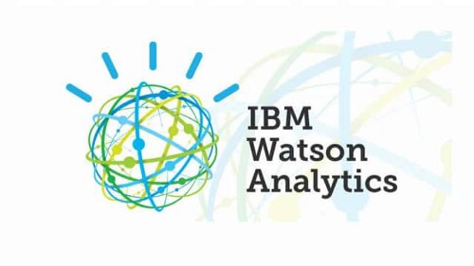

“Watson” is an IBM supercomputer that combines Artificial Intelligence (AI) and complex inquisitive programming for ideal execution as a “question answering” machine. The supercomputer is named for IBM’s founder, Thomas J. Watson.

IBM Watson is at the forefront of the new era of computing. At the point when IBM Watson made, IBM communicated that “more than 100 particular techniques are used to inspect perceive sources, find and make theories, find and score affirm, and combination and rank speculations.” recently, the Watson limits have been expanded and the way by which Watson works has been changed to abuse new sending models (Watson on IBM Cloud) and propelled machine learning capacities and upgraded hardware open to architects and authorities. It isn’t any longer completely a request answering figuring system arranged from Q&A joins yet can now ‘see’, ‘hear’, ‘read’, ‘talk’, ‘taste’, ‘translate’, ‘learn’ and ‘endorse’.

# Machine Learning

### Introduction

Machine learning is a subfield of artificial intelligence (AI). The goal of machine learning generally is to understand the structure of data and fit that data into models that can be understood and utilized by people.

Although machine learning is a field within computer science, it differs from traditional computational approaches. In traditional computing, algorithms are sets of explicitly programmed instructions used by computers to calculate or problem solve. Machine learning algorithms instead allow for computers to train on data inputs and use statistical analysis in order to output values that fall within a specific range. Because of this, machine learning facilitates computers in building models from sample data in order to automate decision-making processes based on data inputs.

Any technology user today has benefitted from machine learning. Facial recognition technology allows social media platforms to help users tag and share photos of friends. Optical character recognition (OCR) technology converts images of text into movable type. Recommendation engines, powered by machine learning, suggest what movies or television shows to watch next based on user preferences. Self-driving cars that rely on machine learning to navigate may soon be available to consumers.

Machine learning is a continuously developing field. Because of this, there are some considerations to keep in mind as you work with machine learning methodologies, or analyze the impact of machine learning processes.

In this tutorial, we’ll look into the common machine learning methods of supervised and unsupervised learning, and common algorithmic approaches in machine learning, including the k-nearest neighbor algorithm, decision tree learning, and deep learning. We’ll explore which programming languages are most used in machine learning, providing you with some of the positive and negative attributes of each. Additionally, we’ll discuss biases that are perpetuated by machine learning algorithms, and consider what can be kept in mind to prevent these biases when building algorithms.

## Machine Learning Methods

In machine learning, tasks are generally classified into broad categories. These categories are based on how learning is received or how feedback on the learning is given to the system developed.

Two of the most widely adopted machine learning methods are **supervised learning** which trains algorithms based on example input and output data that is labeled by humans, and **unsupervised learning** which provides the algorithm with no labeled data in order to allow it to find structure within its input data. Let’s explore these methods in more detail.

### Supervised Learning

In supervised learning, the computer is provided with example inputs that are labeled with their desired outputs. The purpose of this method is for the algorithm to be able to “learn” by comparing its actual output with the “taught” outputs to find errors, and modify the model accordingly. Supervised learning therefore uses patterns to predict label values on additional unlabeled data.

For example, with supervised learning, an algorithm may be fed data with images of sharks labeled as fish and images of oceans labeled as water. By being trained on this data, the supervised learning algorithm should be able to later identify unlabeled shark images as fish and unlabeled ocean images as water.

A common use case of supervised learning is to use historical data to predict statistically likely future events. It may use historical stock market information to anticipate upcoming fluctuations, or be employed to filter out spam emails. In supervised learning, tagged photos of dogs can be used as input data to classify untagged photos of dogs.

### Unsupervised Learning

In unsupervised learning, data is unlabeled, so the learning algorithm is left to find commonalities among its input data. As unlabeled data are more abundant than labeled data, machine learning methods that facilitate unsupervised learning are particularly valuable.

The goal of unsupervised learning may be as straightforward as discovering hidden patterns within a dataset, but it may also have a goal of feature learning, which allows the computational machine to automatically discover the representations that are needed to classify raw data.

Unsupervised learning is commonly used for transactional data. You may have a large dataset of customers and their purchases, but as a human you will likely not be able to make sense of what similar attributes can be drawn from customer profiles and their types of purchases. With this data fed into an unsupervised learning algorithm, it may be determined that women of a certain age range who buy unscented soaps are likely to be pregnant, and therefore a marketing campaign related to pregnancy and baby products can be targeted to this audience in order to increase their number of purchases.

Without being told a “correct” answer, unsupervised learning methods can look at complex data that is more expansive and seemingly unrelated in order to organize it in potentially meaningful ways. Unsupervised learning is often used for anomaly detection including for fraudulent credit card purchases, and recommender systems that recommend what products to buy next. In unsupervised learning, untagged photos of dogs can be used as input data for the algorithm to find likenesses and classify dog photos together.

## Approaches

As a field, machine learning is closely related to computational statistics, so having a background knowledge in statistics is useful for understanding and leveraging machine learning algorithms.

For those who may not have studied statistics, it can be helpful to first define correlation and regression, as they are commonly used techniques for investigating the relationship among quantitative variables. **Correlation** is a measure of association between two variables that are not designated as either dependent or independent. **Regression** at a basic level is used to examine the relationship between one dependent and one independent variable. Because regression statistics can be used to anticipate the dependent variable when the independent variable is known, regression enables prediction capabilities.

Approaches to machine learning are continuously being developed. For our purposes, we’ll go through a few of the popular approaches that are being used in machine learning at the time of writing.

### k-nearest neighbor

The k-nearest neighbor algorithm is a pattern recognition model that can be used for classification as well as regression. Often abbreviated as k-NN, the **k** in k-nearest neighbor is a positive integer, which is typically small. In either classification or regression, the input will consist of the k closest training examples within a space.

We will focus on k-NN classification. In this method, the output is class membership. This will assign a new object to the class most common among its k nearest neighbors. In the case of k = 1, the object is assigned to the class of the single nearest neighbor.

Let’s look at an example of k-nearest neighbor. In the diagram below, there are blue diamond objects and orange star objects. These belong to two separate classes: the diamond class and the star class.

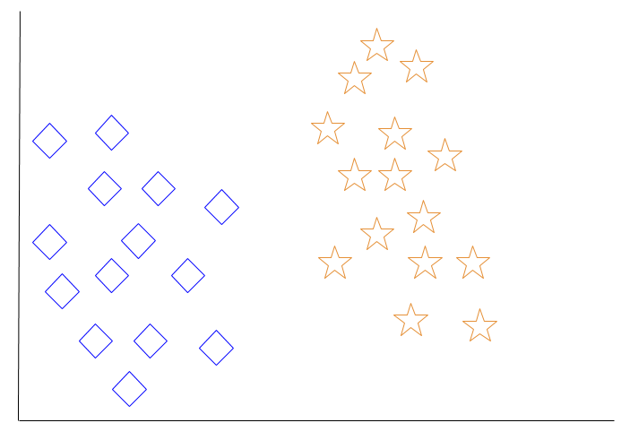

When a new object is added to the space — in this case a green heart — we will want the machine learning algorithm to classify the heart to a certain class.

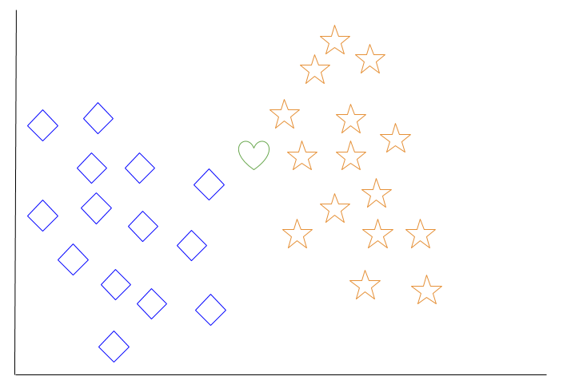

When we choose k = 3, the algorithm will find the three nearest neighbors of the green heart in order to classify it to either the diamond class or the star class.

In our diagram, the three nearest neighbors of the green heart are one diamond and two stars. Therefore, the algorithm will classify the heart with the star class.

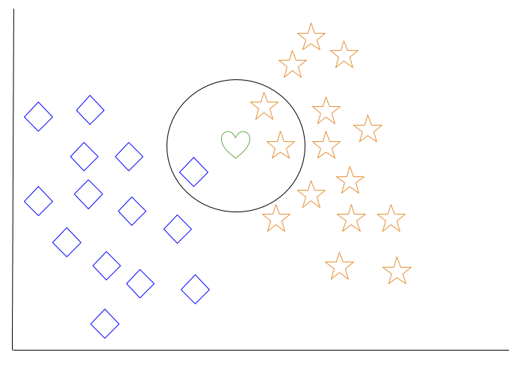

Among the most basic of machine learning algorithms, k-nearest neighbor is considered to be a type of “lazy learning” as generalization beyond the training data does not occur until a query is made to the system.

### Decision Tree Learning

For general use, decision trees are employed to visually represent decisions and show or inform decision making. When working with machine learning and data mining, decision trees are used as a predictive model. These models map observations about data to conclusions about the data’s target value.

The goal of decision tree learning is to create a model that will predict the value of a target based on input variables.

In the predictive model, the data’s attributes that are determined through observation are represented by the branches, while the conclusions about the data’s target value are represented in the leaves.

When “learning” a tree, the source data is divided into subsets based on an attribute value test, which is repeated on each of the derived subsets recursively. Once the subset at a node has the equivalent value as its target value has, the recursion process will be complete.

Let’s look at an example of various conditions that can determine whether or not someone should go fishing. This includes weather conditions as well as barometric pressure conditions.

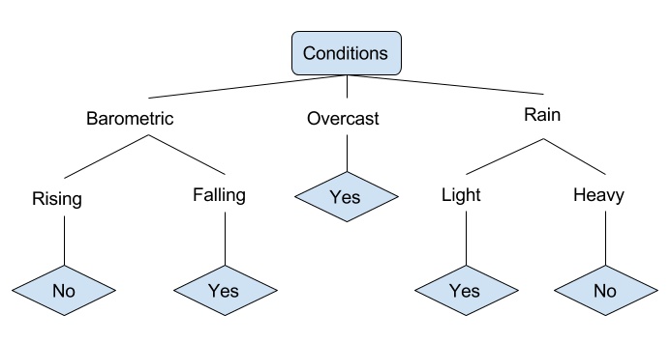

In the simplified decision tree above, an example is classified by sorting it through the tree to the appropriate leaf node. This then returns the classification associated with the particular leaf, which in this case is either a Yes or a No. The tree classifies a day’s conditions based on whether or not it is suitable for going fishing.

A true classification tree data set would have a lot more features than what is outlined above, but relationships should be straightforward to determine. When working with decision tree learning, several determinations need to be made, including what features to choose, what conditions to use for splitting, and understanding when the decision tree has reached a clear ending.

# Introduction to Deep Learning

What is deep learning

Deep learning is a branch of [machine learning](https://www.geeksforgeeks.org/introduction-machine-learning/) which is completely based on [artificial neural networks](https://www.geeksforgeeks.org/tag/neural-network/), as neural network is going to mimic the human brain so deep learning is also a kind of mimic of human brain. In deep learning, we don’t need to explicitly program everything. The concept of deep learning is not new. It has been around for a couple of years now. It’s on hype nowadays because earlier we did not have that much processing power and a lot of data. As in the last 20 years, the processing power increases exponentially, deep learning and machine learning came in the picture.  
A formal definition of deep learning is- neurons

Deep learning is a particular kind of machine learning that achieves great power and flexibility by learning to represent the world as a nested hierarchy of concepts, with each concept defined in relation to simpler concepts, and more abstract representations computed in terms of less abstract ones.

In human brain approximately 100 billion neurons all together this is a picture of an individual neuron and each neuron is connected through thousand of their neighbours.  
The question here is how do we recreate these neurons in a computer. So, we create an artificial structure called an artificial neural net where we have nodes or neurons. We have some neurons for input value and some for output value and in between, there may be lots of neurons interconnected in the hidden layer.

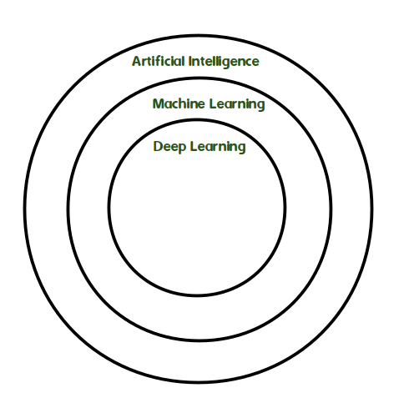

**CHAPTER – 8**

**CODING**

**8.1 Source code**

**CHAPTER – 9**

**SYSTEM TESTING**

**9.1 Testing Methodologies**

The purpose of testing is to discover errors. Testing is the process of trying to discover every conceivable fault or weakness in a work product. It provides a way to check the functionality of components, sub assemblies, assemblies and/or a finished product It is the process of exercising software with the intent of ensuring that the Software system meets its requirements and user expectations and does not fail in an unacceptable manner. There are various types of test. Each test type addresses a specific testing requirement.

### TYPES OF TESTS

**Unit testing**

Unit testing involves the design of test cases that validate that the internal program logic is functioning properly, and that program inputs produce valid outputs. All decision branches and internal code flow should be validated. It is the testing of individual software units of the application .it is done after the completion of an individual unit before integration. This is a structural testing, that relies on knowledge of its construction and is invasive. Unit tests perform basic tests at component level and test a specific business process, application, and/or system configuration. Unit tests ensure that each unique path of a business process performs accurately to the documented specifications and contains clearly defined inputs and expected results.

**Integration testing**

Integration tests are designed to test integrated software components to determine if they actually run as one program. Testing is event driven and is more concerned with the basic outcome of screens or fields. Integration tests demonstrate that although the components were individually satisfaction, as shown by successfully unit testing, the combination of components is correct and consistent. Integration testing is specifically aimed at exposing the problems that arise from the combination of components.

**Functional test**

Functional tests provide systematic demonstrations that functions tested are available as specified by the business and technical requirements, system documentation, and user manuals.

Functional testing is centered on the following items:

Valid Input : identified classes of valid input must be accepted.

Invalid Input : identified classes of invalid input must be rejected.

Functions : identified functions must be exercised.

Output : identified classes of application outputs must be exercised.

Systems/Procedures : interfacing systems or procedures must be invoked.

Organization and preparation of functional tests is focused on requirements, key functions, or special test cases. In addition, systematic coverage pertaining to identify Business process flows; data fields, predefined processes, and successive processes must be considered for testing. Before functional testing is complete, additional tests are identified and the effective value of current tests is determined.

**System Test**

System testing ensures that the entire integrated software system meets requirements. It tests a configuration to ensure known and predictable results. An example of system testing is the configuration oriented system integration test. System testing is based on process descriptions and flows, emphasizing pre-driven process links and integration points.

**White Box Testing**

White Box Testing is a testing in which in which the software tester has knowledge of the inner workings, structure and language of the software, or at least its purpose. It is purpose. It is used to test areas that cannot be reached from a black box level.

**Black Box Testing**

Black Box Testing is testing the software without any knowledge of the inner workings, structure or language of the module being tested. Black box tests, as most other kinds of tests, must be written from a definitive source document, such as specification or requirements document, such as specification or requirements document. It is a testing in which the software under test is treated, as a black box .you cannot “see” into it. The test provides inputs and responds to outputs without considering how the software works.

**Unit Testing**

Unit testing is usually conducted as part of a combined code and unit test phase of the software lifecycle, although it is not uncommon for coding and unit testing to be conducted as two distinct phases.

**Test strategy and approach**

Field testing will be performed manually and functional tests will be written in detail.

**Test objectives**

* All field entries must work properly.
* Pages must be activated from the identified link.
* The entry screen, messages and responses must not be delayed.

**Features to be tested**

* Verify that the entries are of the correct format
* No duplicate entries should be allowed
* All links should take the user to the correct page.

# Integration Testing

Software integration testing is the incremental integration testing of two or more integrated software components on a single platform to produce failures caused by interface defects.

The task of the integration test is to check that components or software applications, e.g. components in a software system or – one step up – software applications at the company level – interact without error.

**Test Results:** All the test cases mentioned above passed successfully. No defects encountered.

**Acceptance Testing**

User Acceptance Testing is a critical phase of any project and requires significant participation by the end user. It also ensures that the system meets the functional requirements.

**Test Results:** All the test cases mentioned above passed successfully. No defects encountered.

**CHAPTER – 10**

**Output Screens (FORMS & REPORTS)**

**CHAPTER – 11**

**FUTURE ENHANCEMENT**

We also evaluated an active defense, where we injected watermarked click traffic into the analysis environment, that works better still. While timing analysis is well studied within the field of information hiding, for its ability to unearth hidden communication, its potential has yet to be fully explored in understanding stealthly click fraud attacks. Our work indicates that timing analysis might indeed be relevant to building better click fraud detection.

**CHAPTER – 12**

**Conclusion**

AdSherlock is an efficient and deployable click fraud detection approach for mobile apps at the client side. As a client-side approach, AdSherlock is orthogonal to existing server-side approaches. It splits the computation intensive operations of click request identification into an offline process and an online process. In the offline process, AdSherlock generates both exact patterns and probabilistic patterns based on url tokenization. These patterns are used in the online process for click request identification, and further used for click fraud detection together with an ad request tree model. Evaluation shows that AdSherlock achieves high click fraud detection accuracy with a negligible runtime overhead. In the future, we plan to combine static analysis with the traffic analysis to improve the accuracy of ad request identification and explore attacks designed to evade AdSherlock.

**CHAPTER – 13**

**REFERENCES**

[1] “Mobile advertising spending worldwide.” [Online]. Available: https://www.statista.com/statistics/280640/mobile-advertisingspending- worldwide/

[2] “Google admob.” [Online]. Available: <https://apps.admob.com/>

[3] M. Mahdian and K. Tomak, “Pay-per-action model for online advertising,” in Proc. of ACM ADKDD, 2007.

[4] G. Cho, J. Cho, Y. Song, and H. Kim, “An empirical study of click fraud in mobile advertising networks,” in Proc. of ACM ARES, 2015.

[5] J. Crussell, R. Stevens, and H. Chen, “Madfraud: Investigating ad fraud in android applications,” in Proc. of ACM MobySys, 2014.

[6] R. Oentaryo, E.-P. Lim, M. Finegold, D. Lo, F. Zhu, C. Phua, E.-Y. Cheu, G.-E. Yap, K. Sim, M. N. Nguyen, K. Perera, B. Neupane, M. Faisal, Z. Aung, W. L. Woon, W. Chen, D. Patel, and D. Berrar, “Detecting click fraud in online advertising: A data mining approach,” The Journal of Machine Learning Research, vol. 15, no. 1, pp. 99–140, 2014.

[7] B. Kitts, Y. J. Zhang, G. Wu, W. Brandi, J. Beasley, K. Morrill, J. Ettedgui, S. Siddhartha, H. Yuan, F. Gao, P. Azo, and R. Mahato, Click Fraud Detection: Adversarial Pattern Recognition over 5 Years at Microsoft. Cham: Springer International Publishing, 2015, pp. 181–201.

[8] A. Metwally, D. Agrawal, and A. El Abbadi, “Detectives: detecting coalition hit inflation attacks in advertising networks streams,” in Proc. of ACM WWW, 2007.

[9] A. Metwally, D. Agrawal, A. El Abbad, and Q. Zheng, “On hit inflation techniques and detection in streams of web advertising networks,” in Proc. of IEEE ICDCS, 2007.

[10] F. Yu, Y. Xie, and Q. Ke, “Sbotminer: large scale search bot detection,” in Proc. of ACM WSDM, 2010.

[11] L. Zhang and Y. Guan, “Detecting click fraud in pay-per-click streams of online advertising networks,” in Proc. of IEEE ICDCS, 2008.

[12] A. Metwally, D. Agrawal, and A. El Abbadi, “Duplicate detection in click streams,” in Proc. of ACM WWW, 2005.

[13] M. S. Iqbal, M. Zulkernine, F. Jaafar, and Y. Gu, “Fcfraud: Fighting click-fraud from the user side,” in Proc. of IEEE HASE, 2016.

[14] B. Liu, S. Nath, R. Govindan, and J. Liu, “Decaf: detecting and characterizing ad fraud in mobile apps,” in Proc. of USENIX NSDI, 2014.

[15] G. Cho, J. Cho, Y. Song, D. Choi, and H. Kim, “Combating online fraud attacks in mobile-based advertising,” EURASIP Journal on Information Security, vol. 2016, no. 1, p. 1, 2016.

[16] W. Li, H. Li, H. Chen, and Y. Xia, “Adattester: Secure online mobile advertisement attestation using trustzone,” in Proc. of ACM MobySys, 2015.

[17] “Monkeyrunner.” [Online]. Available: <http://developer.android.com/studio/test/monkeyrunner/index.html>

[18] “Zedge.” [Online]. Available: <https://play.google.com/store/apps/>

[19] S. Dai, A. Tongaonkar, X. Wang, A. Nucci, and D. Song, “Networkprofiler: Towards automatic fingerprinting of android apps,” in Proc. of IEEE INFOCOM, 2013.

[20] “Mopub.” [Online]. Available: <https://www.mopub.com/>

[21] J. Newsome, B. Karp, and D. Song, “Polygraph: Automatically generating signatures for polymorphic worms,” in Proc. of IEEE S&P, 2005.

[22] “Android montionevent.” [Online]. Available: <https://developer.android.com/reference/android/view/MotionEvent.html>

[23] X. Jin, P. Huang, T. Xu, and Y. Zhou, “Nchecker: saving mobile app developers from network disruptions,” in Proc. of ACM EuroSys, 2016.

[24] J. Davis and M. Goadrich, “The relationship between precision-recall and roc curves,” in Proc. of ACM ICML, 2006.

[25] T. Saito and M. Rehmsmeier, “The precision-recall plot is more informative than the roc plot when evaluating binary classifiers on imbalanced datasets,” PloS one, vol. 10, no. 3, p. e0118432, 2015.